JPacman3 Questions and Answers

**1) What is the role of EmptySprite?**

* EmptySprite is a sprite that doesn't have any data, nor a width or height (these are set to 0). It is used to denote the end of the loop through animationFrames (a list of Sprites) in AnimatedSprite.java. The currentSprite is set to this EmptySprite object by default in the method currentSprite() and is changed it the index of the current frame doesn't exceed the length of animationFrames.

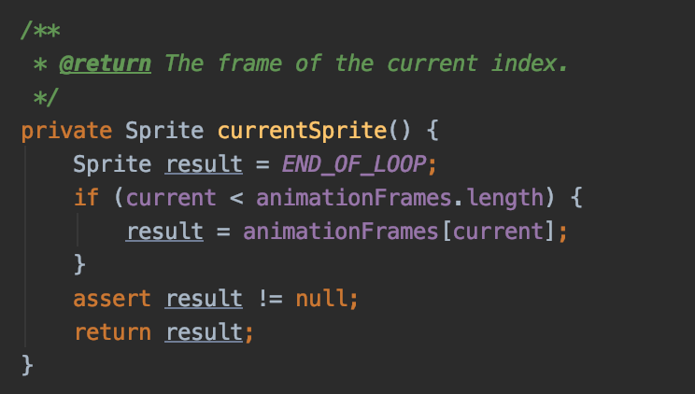

**2) What is the role of MOVE_INTERVAL and INTERVAL_VARIATION?**

* MOVE_INTERVAL is the constant set by each subclass of Ghost (for example Blinky, Clyde, Inky, Pinky) to be set to the moveInterval property of the Ghost abstract class. It is the base constant for the delay time in getInterval().
* INTERVAL_VARIATION is also a constant set by each subclass of Ghost to be set to the intervalVariation property of the Ghost abstract class. It is used as the argument and thus range of the Random().nextInt() method to get back a random number within that interval.
* Both moveInterval which acts as the base constant and intervalVariation which acts as a random addition to the base is used to get a dynamic delay time in milliseconds between each move that a Ghost makes.

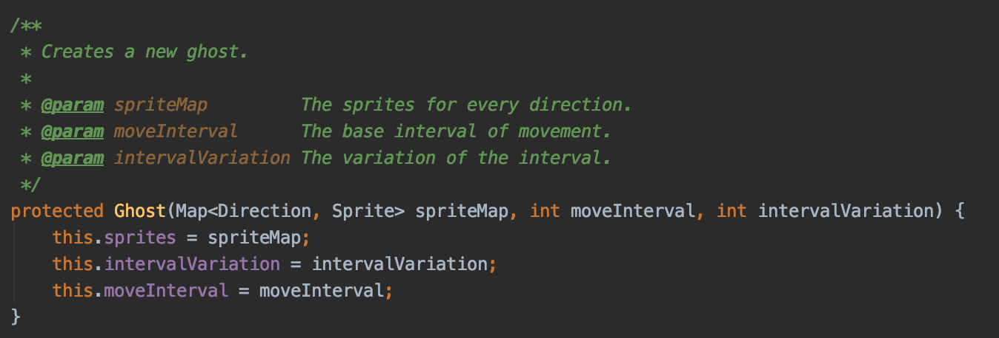

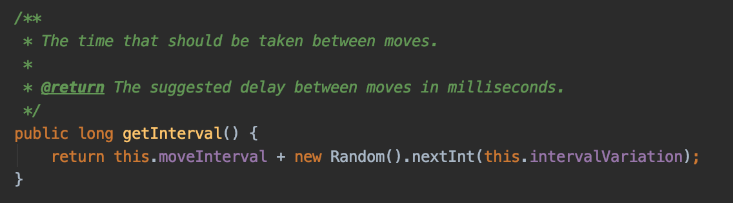

**3) If you wanted to add a fruit, which files would you need to change?**

* One file that we would need to likely change would be PacManSprites.java because it contains methods to load resources based on a given path in the directory. There would be an additional method to load fruits.
* Additionally, the LevelFactory.java file would need to change to include fruits and the number of fruits for that level and on the board. The method createLevel() would need to include fruits as an argument and returns a new Level object with those fruits.

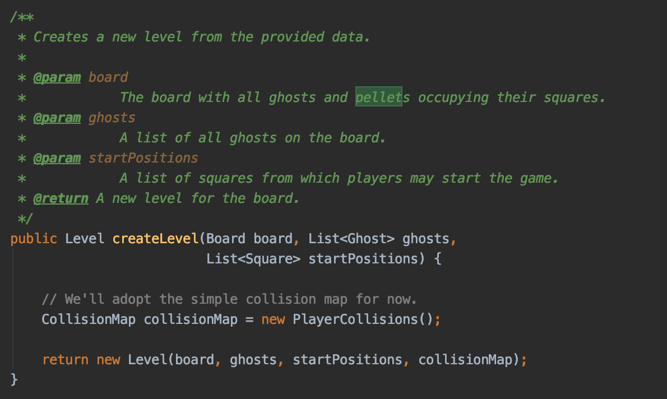

* Level.java will also need to manage those new fruit objects, and thus would also need to be changed.

